Name: TUYISHIME Ange

Id: 24340

Assignment

summary of the Problem Statement for "Tech Haven"

Background:

"Tech Haven," an electronic devices store, faces challenges with inventory management, customer experience, and sales tracking, affecting its overall performance.

Current Issues:

Inventory Management:

Manual tracking leads to discrepancies and stockouts.

Ineffective communication about new products and promotions.

Customer Experience:

Long wait times at checkout.

Limited product information available.

Inadequate feedback mechanisms.

Sales Tracking:

Lack of a comprehensive sales system.

Inconsistent management of promotions.

-- Create Customers table

CREATE TABLE Customers (

CustomerID INT PRIMARY KEY,

Name VARCHAR(100),

ContactInfo VARCHAR(100)

);

-- Create Products table

CREATE TABLE Products (

ProductID INT PRIMARY KEY,

Name VARCHAR(100),

Description VARCHAR(255),

Price DECIMAL(10, 2)

);

-- Create Sales table (foreign keys to Customers and Products)

CREATE TABLE Sales (

SaleID INT PRIMARY KEY,

CustomerID INT,

ProductID INT,

SaleDate DATE,

Amount DECIMAL(10, 2),

FOREIGN KEY (CustomerID) REFERENCES Customers(CustomerID),

FOREIGN KEY (ProductID) REFERENCES Products(ProductID)

);

-- Create Inventory table (one-to-one relationship with Products)

CREATE TABLE Inventory (

InventoryID INT PRIMARY KEY,

ProductID INT,

QuantityAvailable INT,

FOREIGN KEY (ProductID) REFERENCES Products(ProductID)

);

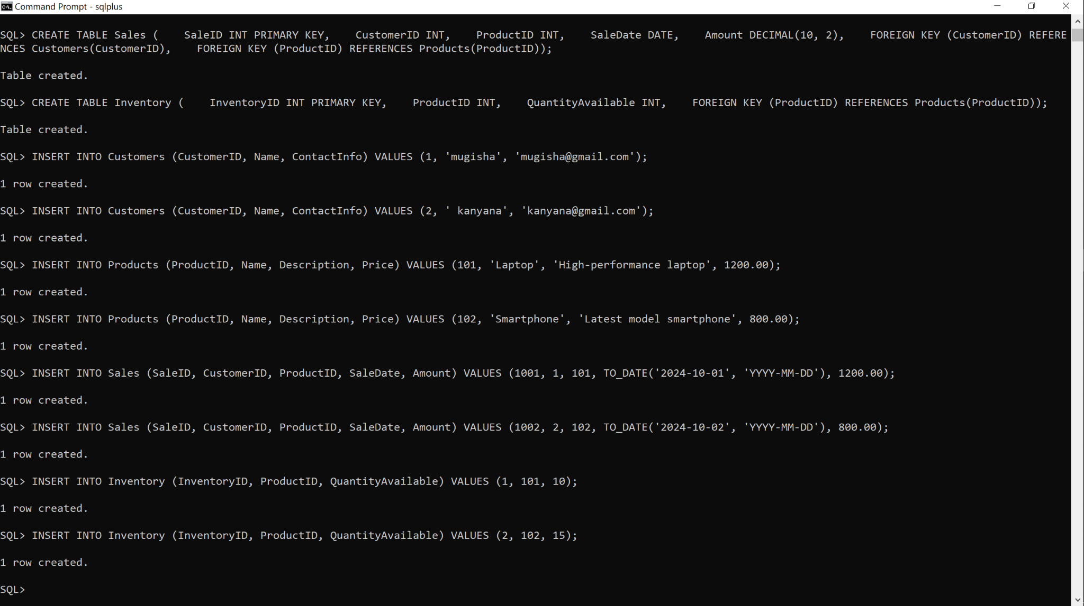

-- Insert Customers

INSERT INTO Customers (CustomerID, Name, ContactInfo)

VALUES (1, 'mugisha', 'mugisha@gmail.com');

INSERT INTO Customers (CustomerID, Name, ContactInfo)

VALUES (2, ' kanyana', 'kanyana@gmail.com');

-- Insert Products

INSERT INTO Products (ProductID, Name, Description, Price)

VALUES (101, 'Laptop', 'High-performance laptop', 1200.00);

INSERT INTO Products (ProductID, Name, Description, Price)

VALUES (102, 'Smartphone', 'Latest model smartphone', 800.00);

-- Insert Sales

INSERT INTO Sales (SaleID, CustomerID, ProductID, SaleDate, Amount)

VALUES (1001, 1, 101, TO_DATE('2024-10-01', 'YYYY-MM-DD'), 1200.00);

INSERT INTO Sales (SaleID, CustomerID, ProductID, SaleDate, Amount)

VALUES (1002, 2, 102, TO_DATE('2024-10-02', 'YYYY-MM-DD'), 800.00);

-- Insert Inventory

INSERT INTO Inventory (InventoryID, ProductID, QuantityAvailable)

VALUES (1, 101, 10);

INSERT INTO Inventory (InventoryID, ProductID, QuantityAvailable)

VALUES (2, 102, 15);



Update Data

sql

Copy code

-- Update product price

UPDATE Products

SET Price = 1300.00

WHERE ProductID = 101;

-- Update inventory quantity

UPDATE Inventory

SET QuantityAvailable = 9

WHERE ProductID = 101;

Delete Data

sql

Copy code

-- Delete a sale record

DELETE FROM Sales

WHERE SaleID = 1002;

-- Delete a product

DELETE FROM Products

WHERE ProductID = 102;

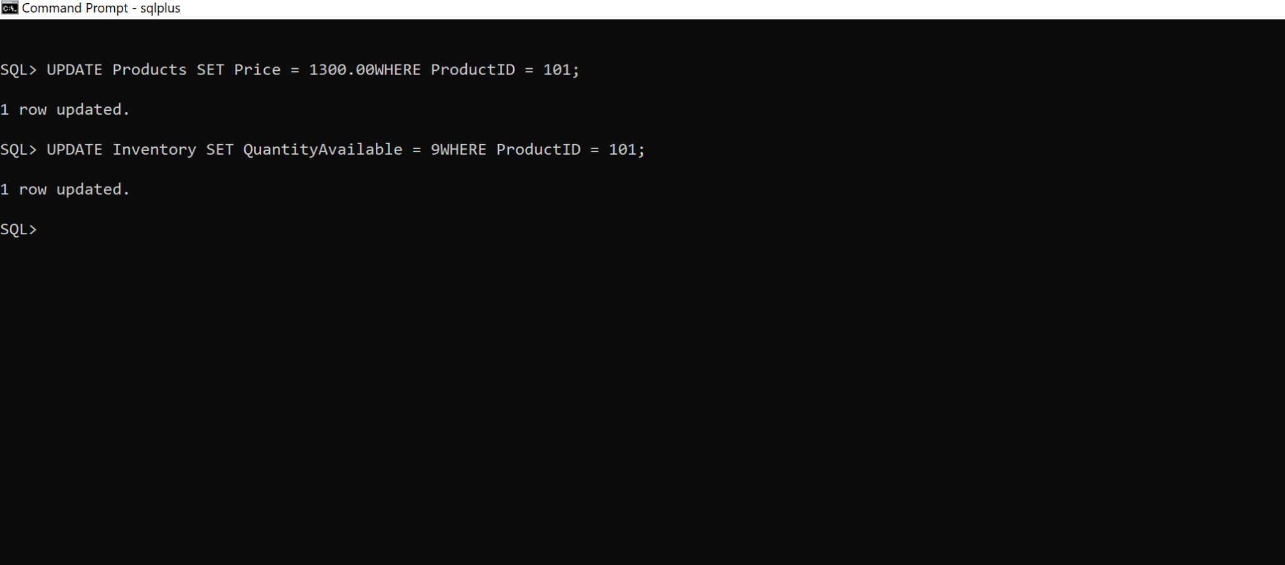

-- Retrieve all sales with customer and product information

SELECT Customers.Name AS CustomerName, Products.Name AS ProductName, Sales.SaleDate, Sales.Amount

FROM Sales

JOIN Customers ON Sales.CustomerID = Customers.CustomerID

JOIN Products ON Sales.ProductID = Products.ProductID;

Subquery to Check Stock Before a Sale

sql

-- Check if a product is in stock before processing a sale

SELECT ProductID, QuantityAvailable

FROM Inventory

WHERE ProductID = (SELECT ProductID FROM Products WHERE Name = 'Laptop');

